**MSEG 302 – Midterm 1 – 9 March 2017**

**Test 2**

Student Name ____________________________________________

Student Number __________________________________________

**Answer each question on the Scantron form noting how much each question is worth, the entire exam is worth 100 points. Each question is worth 3 points (last one is worth 1 point).**

1. If an element has one electron in the “s” orbital then it is called:

a. inert gas b. halogen

c. alkali metal d. transition metal

2. It is possible for a chemical compound to have 100% ionic character.

a. true b. false

3. How many electrons does the element Zinc have?

a. 30 b. 31 c. 65 d. 66

4. Match the electron structure below with the element it represents: 1s22s22p63s23p64s1

a. Li b. Na c. K d. F e. Cl

5. The Mg+2 ion has the equivalent electronic structure of what inert gas?

a. Argon b. Krypton c. Neon d. Helium e. Xenon

6. Molybdenum (Mo) has a density of 10.2 g/cc, an atomic radius of 0.1363 nm, what crystal structure does it have?

a. HCP b. BCC c. FCC d. Simple Cubic

d. None of the these

7. The X-ray radiation Cu K is produced by:

1. Radioactive decay
2. The nucleus releasing a proton
3. Light striking the surface of Copper metal
4. Gaining an electron to make a new isotope
5. None of the above

8. Nickel has an FCC structure and a density of 8.90 g/cc what is its atomic radius?

a. 0.125 nm b. 0.255 nm

c. 0.313 nm d. 0.430 nm

Questions 9 – 11 refer to the following picture.

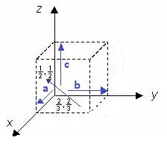

9. What is the x coordinate for the end (where the arrow head is) of the vector?

a. 0 b. ½ c. 1 d. - ½

10. What is the y coordinate for the end (where the arrow head is) of the vector?

a. 0 b. ½ c. 1 d. - ½

11. What are the índices of the vector (a negative value is indicated by a negative sign rather than an overbar)?

a. [-101] b. (-101) c. [-1-43] d. (-1-43)

_______________________________________

12. What are the Miller índices of the plane?



a. (301) b. (311) c. [301] d. [311]

13. Iron has a BCC crystal structure and an atomic radius of 0.126 nm determine the interplanar distance for the (110) set of planes.

a. 0.126 nm b. 0.206 nm

c. 0.891 nm d. 0.218 nm

14. The diffraction angle using CuKα radiation for the (110) set of planes for a unit cell with a lattice parameter of 0.291 nm is:

a. 22.0o b. 44.0o c. 11.0o d. 33.0o

15. In theory, it is possible to produce a crystal that does not have any vacancies if it:

a. has many grains b. the grains are small

c. the grains are large d. it is a single crystal

16. What are the two fundamental types of dislocations?

a. grain b. burgers c. lattice

d. b. and c. e. none of the above

17. A cubic crystal system has:

a. FCC crystal structure

b. HCP crystal structure

c. BCC crystal structure

d. both a and b

e. both a and c

18. When the term “first order reflections” is used regarding this equation: , this means;

a. *dhkl* is an integer b.  is less than 90°

c. * *is 0.1 nm d. *n* is equal to 2

e. none of the above

19. The crystal structure of this material is:

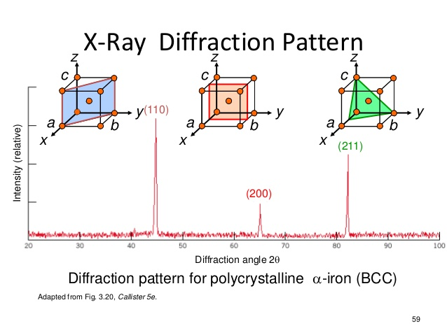

a. HCP b. FCC c. Simple cubic d. BCC

20. If the planes were not written on the peaks in Problem 19 could you have determined what crystal structure it was?

a. yes b. no

21. What type of interference is necessary to characterize a material with x-ray scattering?

a. constructive b. destructive

c. no interference d. both a. and b.

22. It is possible to determine the number of vacancies in a material by:

a. using x-ray scattering b. measuring the length of a bar as it is heated c. measuring its mass as a function of temperature

d. both a. and b. e. using a., b. and c.

23. Grain boundaries are:

a. point defects b. line defects c. area defects

d. all the above e. none of the above

24. A mixture of two metallic elements usually has which outcomes:

a. producing point defects b. making a solid solution c. making a solid solution plus a new phase d. none of the above e. all the above

25. The Hume-Rothery rules include:

a. the number of neutrons in an element

b. the element’s density

c. the crystal structure of pure metals

d. none of these

e. all of these

26. An alloy consists of 37.1 wt% Pb and the rest Sn, what is the atomic composition of Pb.

a. 37.1 % b. 62.9% c. 25.3% d. 74.7%

27. The equilibrium fraction of vacant lattice sites in Silver is 10-6 at 600°C, calculate the number of vacancies at this temperature. The density of Silver is 10.35 g/cc.

a. 5.78×1022 #/m3 b. 5.78×1016 #/m3

c. 5.58×1021 #/m3 d. 6.23×1024 #/m3

28. Calculate the number of vacancies per cubic meter at 1000°C for a metal that has an energy for vacancy formation of 1.22 eV/atom, a density of 6.25 g/cc, and an atomic weight of 37.4 g/mol.

a. 1.49×1024 #/m3 b. 1.49×1018 #/m3

c. 7.18×1022 #/m3 d. 2.57×1024 #/m3

29. You have the x-ray scattering position of the first peak for an unknown element, why can’t you use just the first scattering peak to determine what element it is?

a. you don’t know how many vacancies it has

b. you need to know its density too

c. you don’t know its lattice parameter

d. you don’t know its crystal structure

e. both c. and d.

30. How many scattering peaks do you need to know to determine if a material has a simple cubic or body centered cubic crystal structure?

a. 1 b. 3 c. 5 d. 7 e. 9

31. Determine the crystal structure of this material.

a. Simple cubic b. FCC c. BCC d. none of these

32. Determine the lattice constant for the material in Problem 31 assuming CuKα radiation is used.

a. 0.154 nm b. 0.330 nm

c. 0.293 nm d. 0.564 nm

33. A metallic element is dense because:

a. it has non-directional bonding

b. it has ionic bonding

c. it has covalent bonding

d. it can have FCC crystal structure

34. Materials Science is:

a. amazing b. extremely interesting

c. helpful d. all of the above

|  |
| --- |
| **_____________________________________________________________________________________**  **Values of Selected Physical Constants** |
| | **Quantity** | **Symbol** | **SI Units** | **cgs Units** | | --- | --- | --- | --- | | Avogadro's number | *N*A | 6.022 × 1023 molecules/mol | 6.022 × 1023 molecules/mol | | Boltzmann's constant | *k* | 1.38 × 10−23 J/atom · K | 1.38 × 10−16 erg/atom · K  8.62 × 10−5 eV/atom · K | | Bohr magneton | *μ*B | 9.27 × 10−24 A · m2 | 9.27 × 10−21 erg/gaussa | | Electron charge | *e* | 1.602 × 10−19 C | 4.8 × 10−10 statcoulb | | Electron mass | — | 9.11 × 10−31 kg | 9.11 × 10−28 g | | Gas constant | *R* | 8.31 J/mol · K | 1.987 cal/mol · K | | Permeability of a vacuum | *μ*0 | 1.257 × 10−6 henry/m | unitya | | Permittivity of a vacuum | ϵ0 | 8.85 × 10−12 farad/m | unityb | | Planck's constant | *h* | 6.63 × 10−34 J · s | 6.63 × 10−27 erg · s  4.13 × 10−15 eV · s | | Velocity of light in a vacuum | *c* | 3 × 108 m/s | 3 × 1010 cm/s | |

CuK radiation wavelength is 0.154 nm.